**A paper on Creating World Map Report in SQL Server Reporting Services (SSRS)**

By

Sadhana Suman (424972)

# Introduction

SQL Server 2008 R2 introduced several new features in the SSRS (SQL Server Reporting Services). In the data visualization category, we now have three additional ways to display and visualize/analyze data in the reports.

* Sparkline and data bars – Sparkline and data bars are normally used inside tables and matrices to analyze the trend and series, and compare them with each other.
* Indicator reports – As the name implies, indicators have icons to represents trends (up, down or flat), progress state, conditions.
* Map reports – Map reports allow creating maps or map layers to let us visualize data against a geographic background.

This white paper will explain about the Map Reports, how we can create Map reports, how to show spatial data in the reports, how to relate spatial data and analytical data, what are the different sources of spatial data etc.

# MAP Reports

Data can be visualized against a geographical background using a map in a report. The type of map can be different depending on the requirement. Example: We can select a bubble map, line map, marker map or a map which shows locations.

A map contains a title, a viewport that specifies the center point and scale, an optional Bing map tile background for the viewport, one or more layers that display spatial data, and a variety of legends that help users interpret the data visualizations.

## Creating a Map Report

Create a SSRS project and add a report to the project. For creating a map report, two sets of data is required: spatial data and analytical data. We can create the spatial and analytical data sources and datasets in advance or if we have not created it in advance then the map wizard will give option to create it on the go.

To add a map to a report, drag the Map report item from the Toolbox to the designer area:

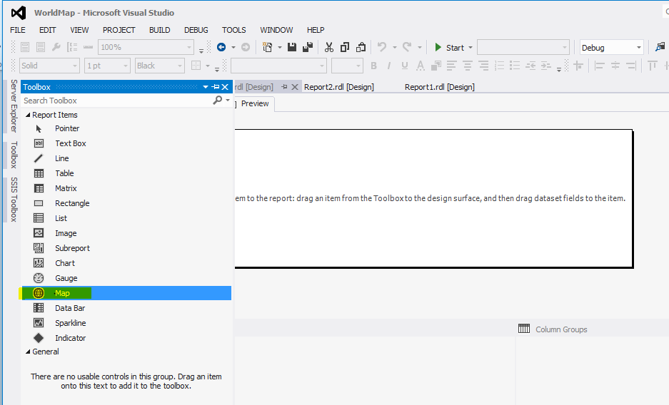

When a Map report item is dragged from the Toolbox to the designer area, a wizard will be launched to specify the map layer detail for the map. On the first page of the New Map Layer wizard specify the source for the spatial/geographical data that contains set of coordinates that define the map areas.

## Source of Spatial Data

The wizard provides three options to choose for the source of spatial data:

### **Map Gallery**

The map gallery contains maps from reports that are located in the map gallery folder for the report authoring environment. Maps from the gallery provide a quick start to add a map to our reports. SSRS provides maps for United States by default in its map gallery. To extend the map gallery, we can add or remove reports from the map gallery directory, and add folders to organize the maps.

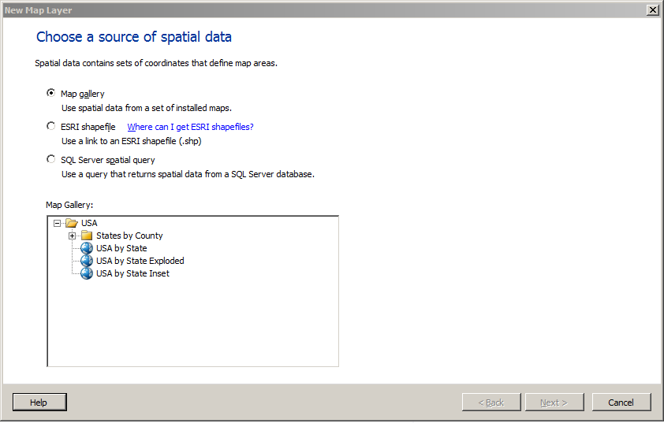

### **ESRI Shapefiles**

An ESRI Shapefile is a set of files with data that conforms to the Environmental Systems Research Institute, Inc. (ESRI) shapefile spatial data format. The set of files typically includes the <filename>.shp file that contains the spatial data and a support file <filename>.dbf. Shapefiles can be downloaded from web (ex: [http://diva-gis.org](http://diva-gis.org/)). Data in the .shp file specifies the geographical or geometrical shapes. Data in the .dbf file provides attributes for the shapes. To view a map in design view or to run a map from the report server, both files must be in the same folder. When we add spatial data from a .shp file to our local file system, the spatial data is embedded in our report.

The drawback with ESRI shapefiles is that we need to have one that shows the data at the level we would like to show it. For example if we have a shapefile that contains all the countries and their borders and we have a requirement to show data on a continent level, then we cannot manipulate the existing shapefile to show data on a continent level. In that case we need to find a shapefile that contains the continents instead.

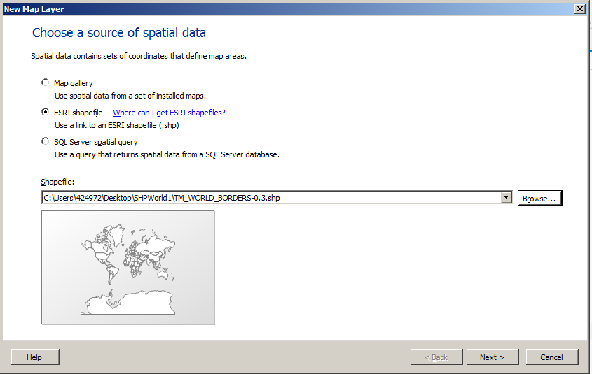

### **SQL Server spatial Query**

To use this option we need to import the shapefile to a SQL Server table. There are tools available to import shapefile to SQL Server table. For example: Shape2SQL. After importing shapefiles to a table, we can select the option ‘SQL Server Spatial query’ from the list and can use the spatial data from the table to show map on our report. SQL Server 2012 comes with a complete set of spatial functions that we can in our queries to create a custom map.

Here we will use the SQL Server Spatial query option for this demonstration.

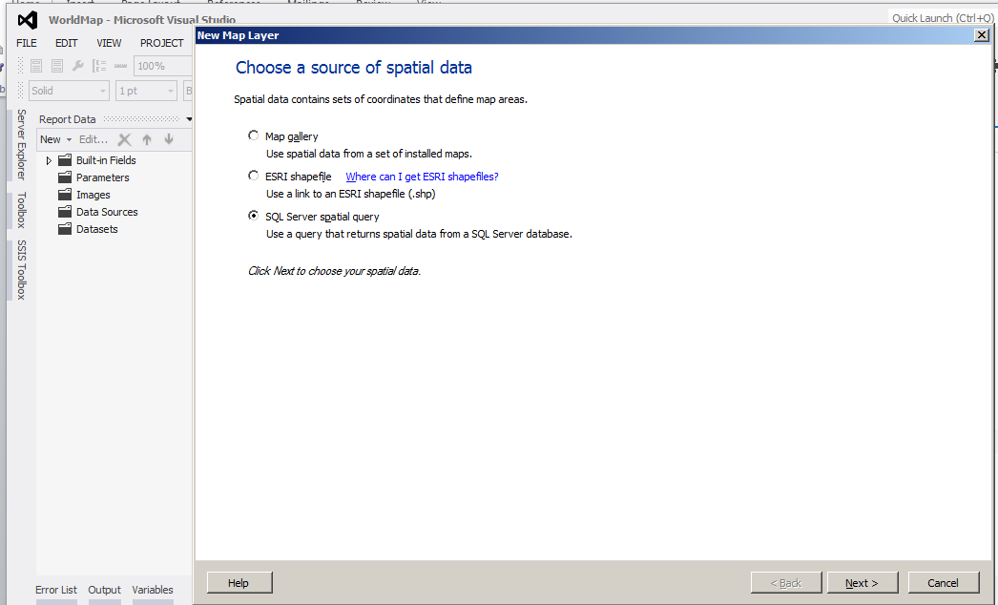  
- Choose a source of spatial data.

On the next screen select a dataset for spatial data if you have already created it or you can create a new dataset for spatial data. Here we will select the Add a new dataset option.

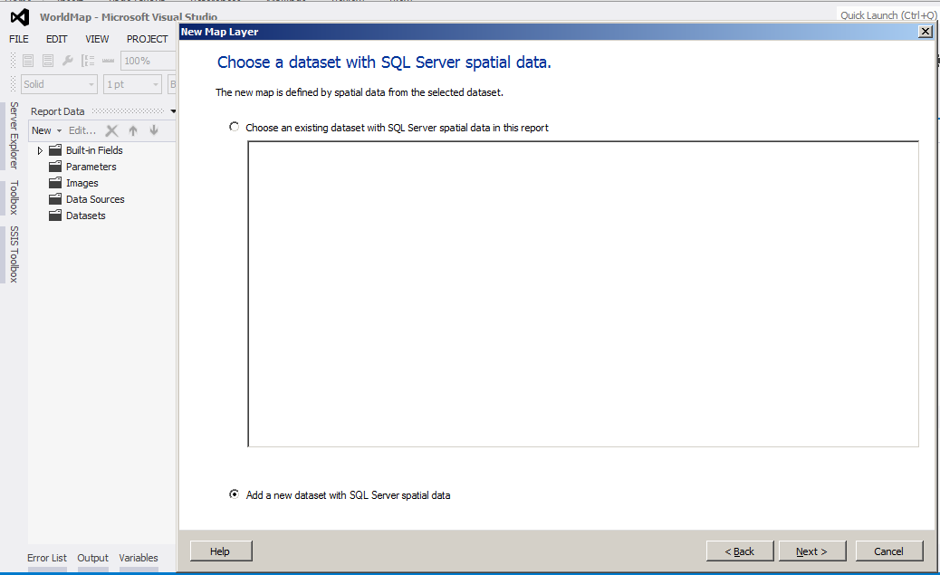

On the next screen of the wizard create a new data source for spatial data.

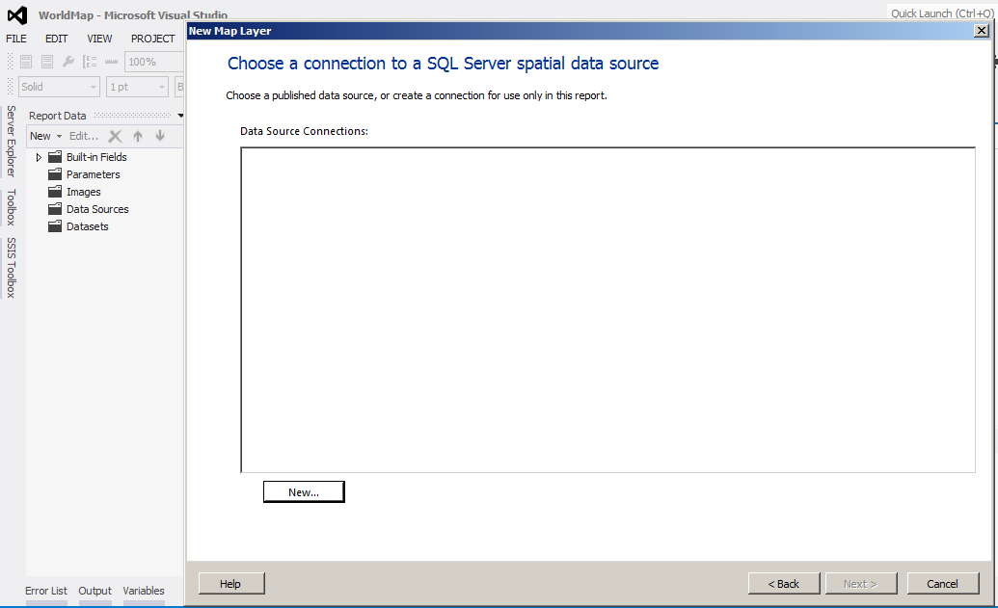

After clicking ‘new’, a new window will open. Here we have option to create a new data source or we can use a shared data source reference.

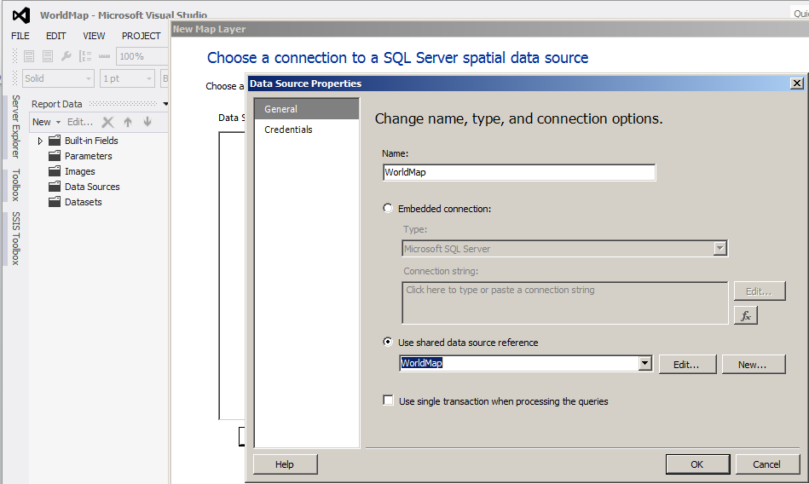

Next, write query for the spatial dataset to fetch spatial data on the report.

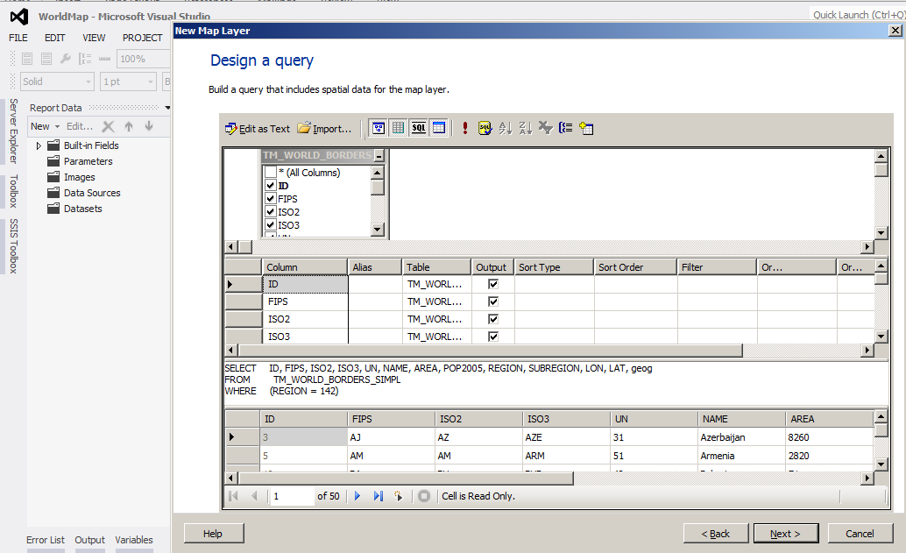

## Map Viewing Options

On the next screen of the wizard specify the map viewing options, such as map resolution (for example high resolution brings the high quality but is heavy weight in terms of performance), Layer type (Polygon, Point or line), changing the location of the map using arrows, setting up the zoom level of the map according to the requirement using plus (+) and Minus (-) sign, adding a Microsoft Bing Map Layer to the map, etc. as shown below:

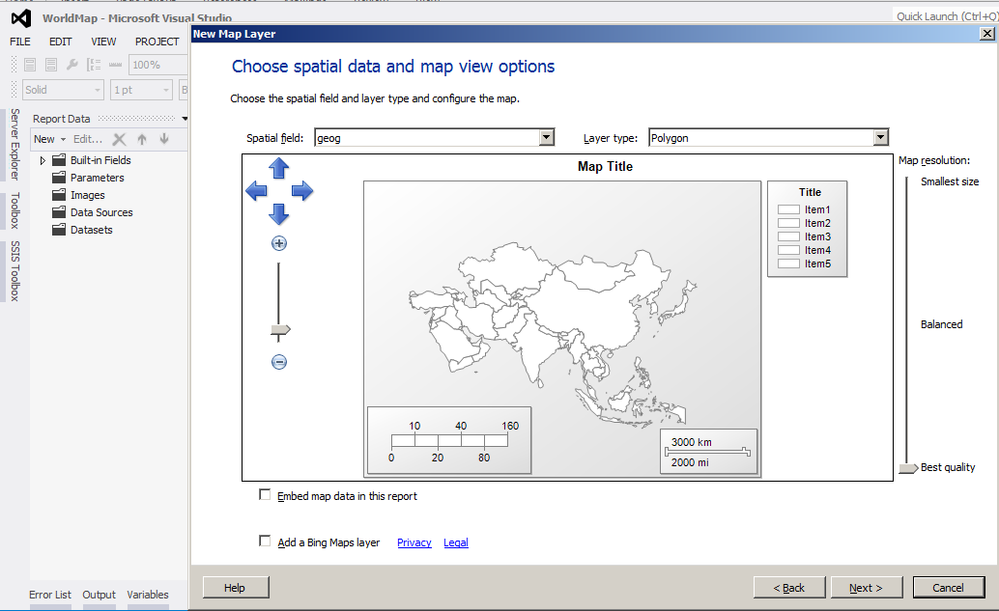  
- Choose spatial data and map view options.

### Em**bedding Map Data in the Report**

If the checkbox for embedding map data in the report is checked in the above screen of the wizard then, the spatial data of the report will be stored in the report definition. Embedded map elements can significantly increase the size of the report definition, but reduce the time it takes to view the map in the report. Dynamic map elements reduce the report definition size but increase the time it takes to process and view the map.

### Adding a Bing Map Layer

Check the checkbox given in the above screen for adding a Bing map layer. The report processor will download the tiles from Bing Maps Web Services for the map area and resolution that is specified in the wizard page. To add a tile layer, the coordinate system must be geographic and the projection type Mercator.  We can specify one of the following tile types:

* **Road:** Display a road map style with white background.
* **Aerial:**Display an aerial view only. No text is displayed in this mode.
* **Hybrid:** Display the combination of **Road** and **Aerial** views.

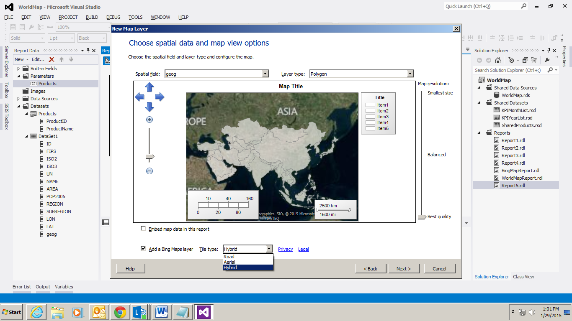

## Map Visualization

On the next page of the wizard specify the map visualization option (it varies from the type of map layer we chose and will have a different screen if we choose a map layer other than Polygon). We the following options:

* **Basic Map:** It displays locations only. The colors of the areas on the map can vary by shade, but the color does not represent analytical data values.
* **Bubble Map:** It conveys the relative value for a single analytical data aggregate as bubble size, for example, store sales. Bubble maps can be created for either polygons or points. For polygons, set the polygon center point properties; for points, set the marker properties.
* **Color Analytical Map:** It conveys the relative value of one or more analytical data aggregates for each map element. For example, store sales as marker size, profit range for product categories as marker color, and top selling product as marker type.

Here for this demonstration, we will use the Color Analytical Map.

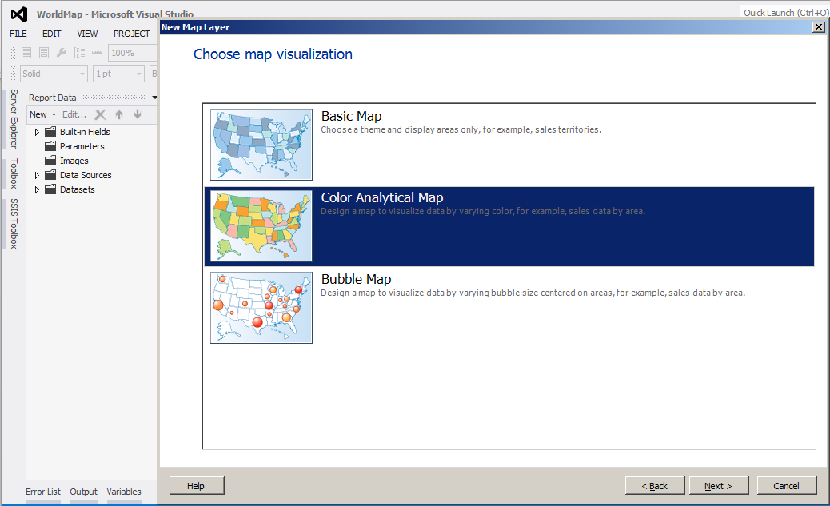  
- Choose map visualization.

## Analytical Dataset

On the next page of the wizard specify the analytical dataset if it is already created or create a new analytical dataset. The analytical dataset must have a field to relate with the spatial data that we have created earlier. Analytical dataset fetches data from the data mart which we want to show on the map. Here we are going to create a new analytical dataset.

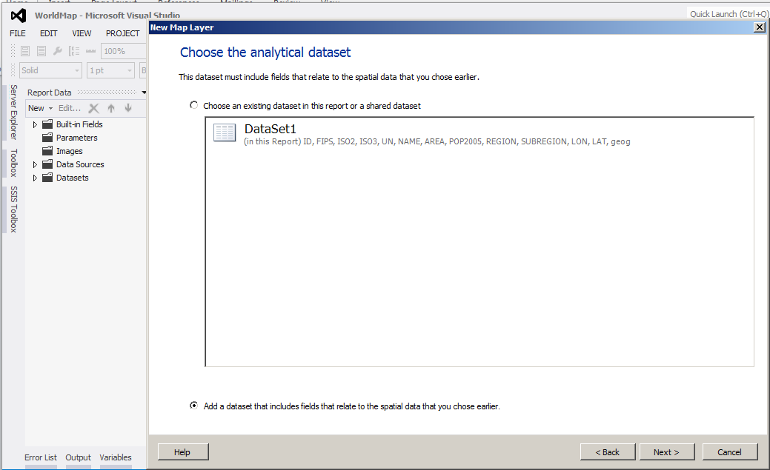

On the next page of the wizard select an existing data source for analytical dataset or create a new data source. Here we are going to use the existing data source.

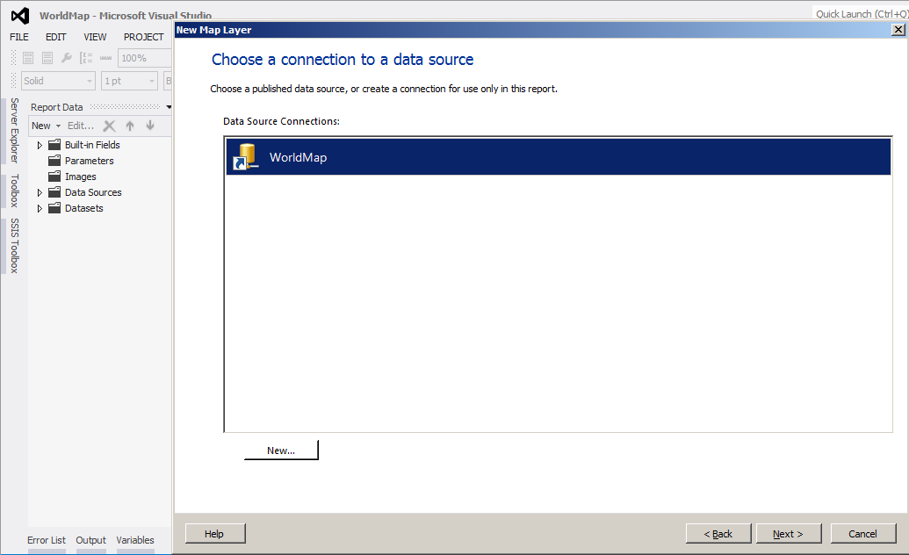

On the next page of the wizard, design query for the analytical dataset to fetch appropriate data which we want to show on the map. Here we have one report parameter @products.

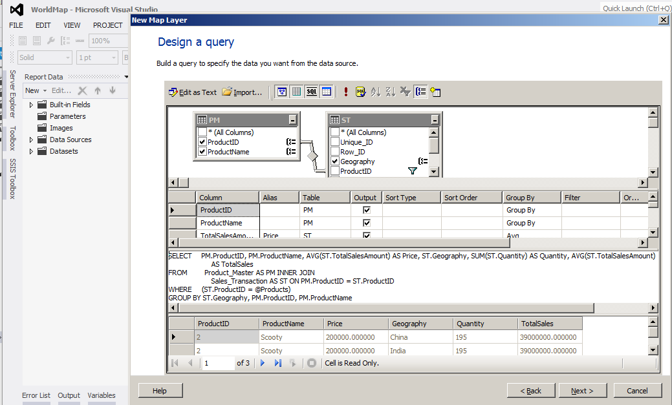

Next, specify the match fields for spatial and analytical data.

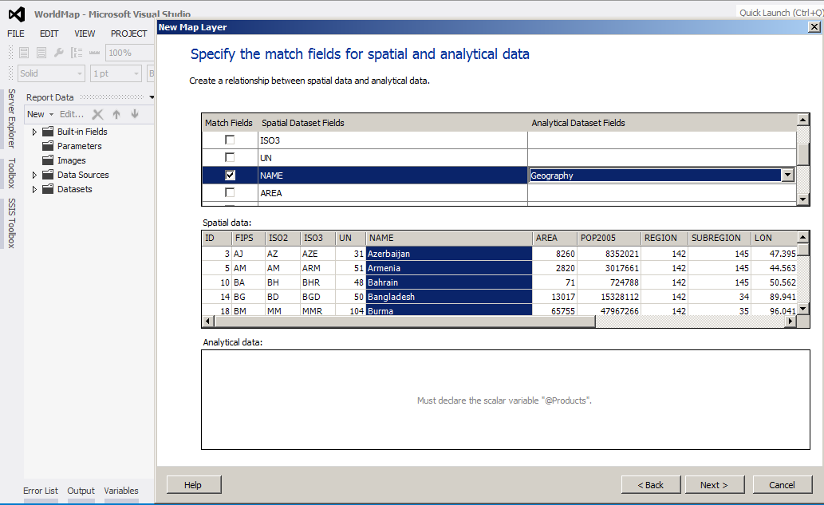

## Color Theme

On the next page of the wizard specify the color theme and data visualization option as shown below. There are already some inbuilt themes, which we can choose or customize the map later as and when needed:

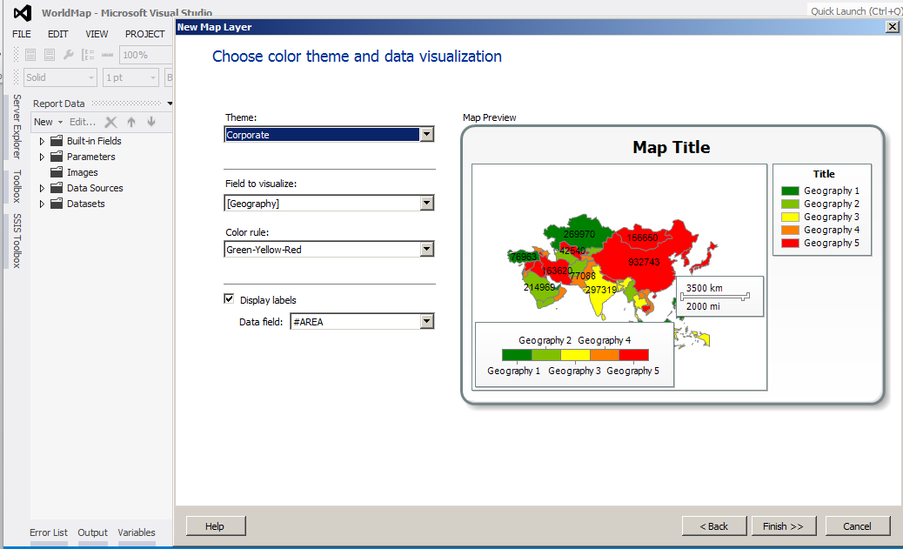

Now if we have data source and data set added to the report. Click on the finish button to complete the wizard. Now the report is ready for preview, but we need to set some basic properties of the map to make it more meaningful for its users.

# Properties of Map

From the Map Layer window select the map layer for which we need to set the properties and click on the tiny icon on the right most side as shown below.

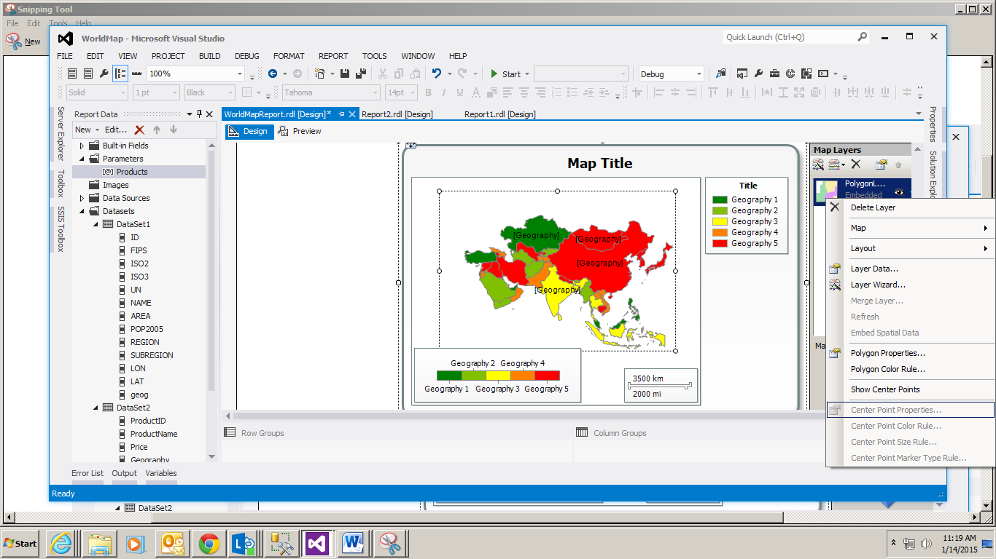

## Layer data

It will open a window which allows changing the spatial as well as the analytical data of the map. It will also allow changing the relationship between the spatial and analytical data.

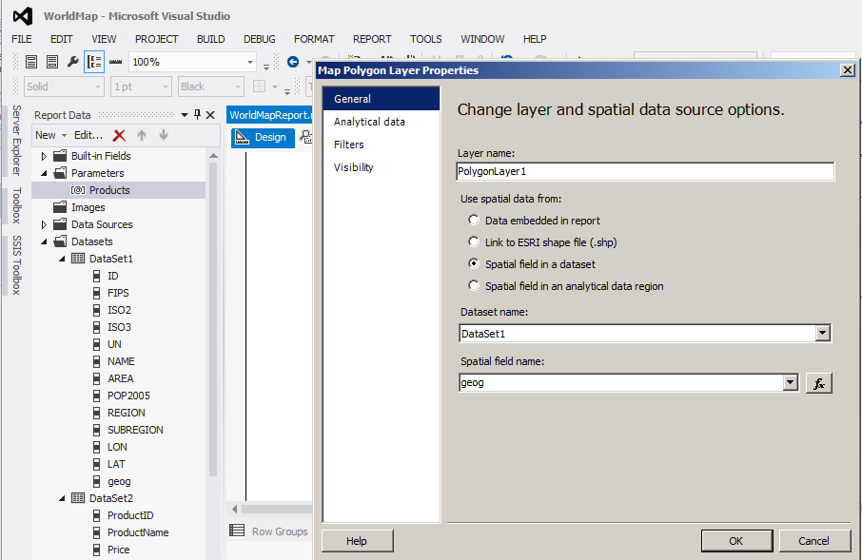

## Layer Wizard

This will open the map wizard again and allow changes.

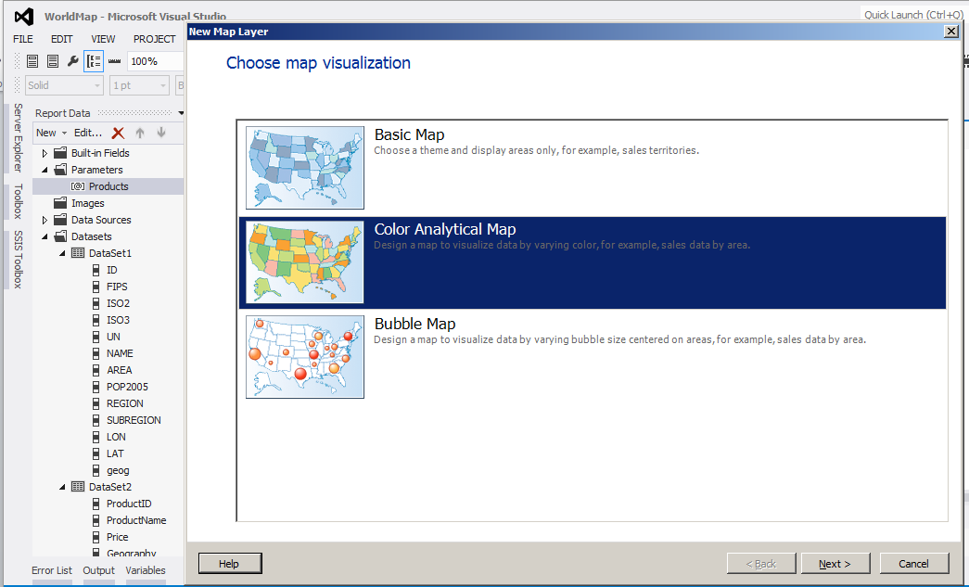

## Polygon Color Rule

This will open a window which allows setting the color rules on the report. Select the ‘Polygon Color Rule’ property; a new window will open. Here we have four options to set the color rule for the map. For this demonstration we will select the option ‘Visualize data by using color ranges’. From the data field drop down select the field on which we need to set the color rule. Here we can select the colors also for different ranges.

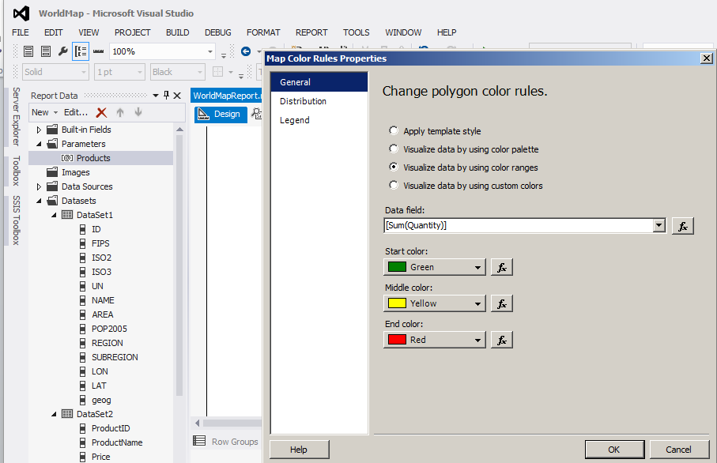

Next, click on ‘Distribution’ to set the range values. Select a distribution option to divide data into sub ranges. Here for demonstration purpose we will select ‘Custom’ option. Then specify the bucket value for sub ranges and click ok.

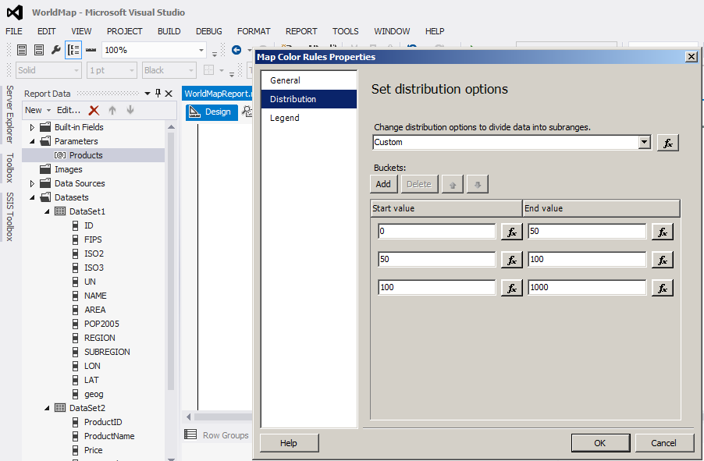

## Map Viewport Properties

Viewport represents the area of a map to be displayed, expressed in world coordinates and (optionally) screen (window, image) coordinates. A viewport is used to stage information for map rendering.

Some important options provided by Map Viewport Properties dialogue box are:

* **General:** This option allows changing the coordinate system, the projection, and the boundary options.

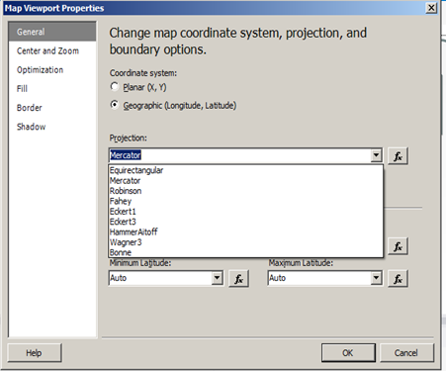

* **Center and Zoom:** This option allows setting the center view and zooming factor for a map. After specifying a map data source and the boundaries of the map that is to include in the report, we can specify the view center and the zoom factor to further control the map display. Options changes depending on which method is selected to specify the center and zoom values.

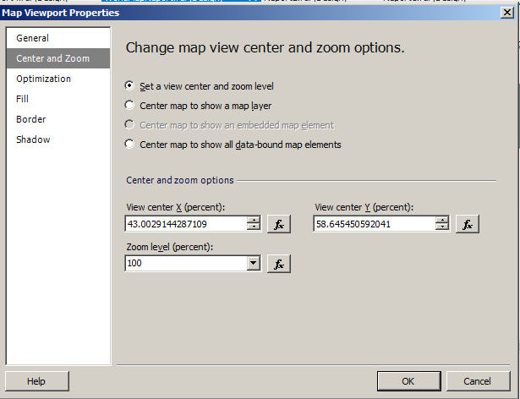

* **Optimization:** It allows changing the resolution of the map to simplify map on all layers.

## Map Title

We can set the title of the map to represent what we are going to display on the report. Here for this report, we are displaying the name of the product selected from the parameter list in the map title.

We can set many more properties of map to make it more presentable and meaningful based on the requirement.

Now the report is ready for preview.

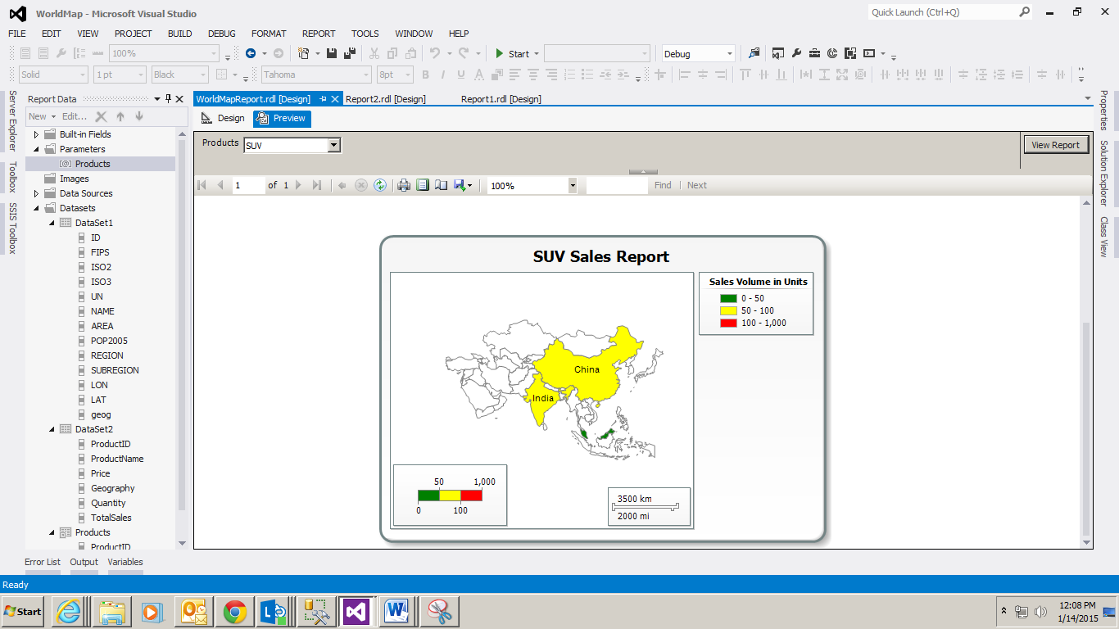

-- End of the Document --